New Product Update

Fever Detection Solution
The COVID -19 Pandemic has exploded and reached unprecedented levels. Early detection can save lives.
Jacky’s has partnered with Axis Communications a leading CCTV company and has come up with a Temperature Alarm camera for remote temperature monitoring. Deploy “Temperature Detection solutions” to detect people running high temperature in order to prevent the spread of the infection.
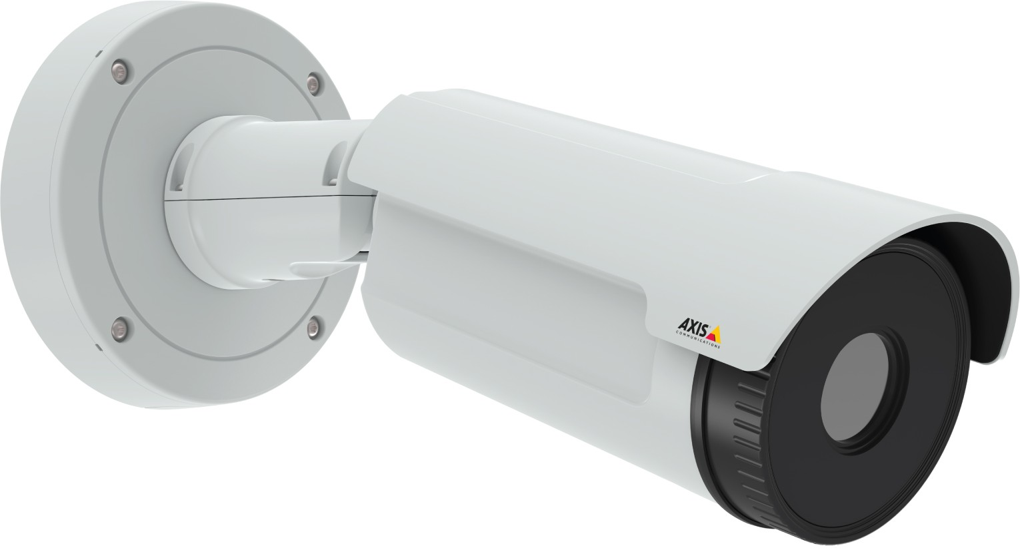
Axis Q2901-E is suitable for both indoor and outdoor which delivers thermal imaging in 336x256 resolution. It supports up to six temperature alarm zones that can be used to trigger an alarm. It offers two kinds of alarms triggered by a deviation in temperature: when the temperature goes beyond a set limit or if it increases too rapidly.
The spot temperature functionality is used to view the temperature of a location. Isothermal palettes highlight temperature spans in the image, making it easier to visualize hot spots to identify overheated objects!
Jacky’s Business Solutions has combined the camera with Human Temperature control software which can perform with 98.4% accuracy when compared with manual temperature measurement.
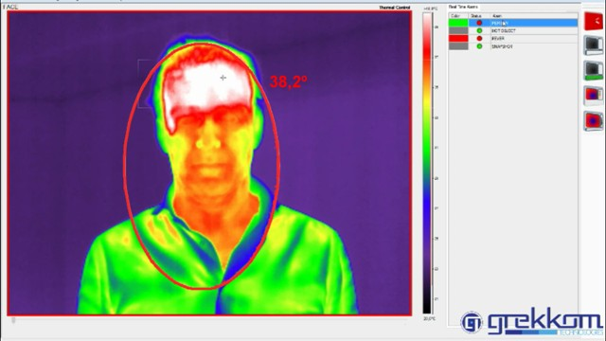
Our solutions are suitable for

Scenarios
- Airports
- Cruises
- Border Control
- Hospitals
- Schools
- Government Buildings
- Office Buildings
- Industrial Facilities

Competitive advantages
- Critical real-time reporting Real-time reporting of temperature reading for rapid commissioning and management
- AXIS ACAP compatible (Edge based solution)
- Detects and triggers an alarm for every individual exceeding the fixed temperature
- Available on fixed or Portable set-ups
- Automatic activation/block access control protocols
- Heat emission and distance configuration available by mask configurator
- Temperature Color palette editor. Allows you to adjust temperature colors to target temperatures
- Image adjustments by enhance or lineal temperature
- Intuitive mask design editor
- Image or video capture responding to alarms
- Friendly & fast configuration

If you wish to have more details or a personal demonstration, please contact Jacky’s Business Solutions LLC., Jane.Victorioso@jackys.com or reach us on our office number 04-3388900

